Producer to Venue:

theatre marketing toolkit
Are you a theatre producer supplying work to a venue? This pack will guide you through creating the information the venue needs to get people through the doors of your show.
Venues have several shows to market at one time. Providing them with easy-to-use information makes it much more likely that they will market your show effectively.
You know your product better than anyone. The venue can use this to tell their audience about your show.

This pack is aimed at three different people at the venue:

Section 1: Venue marketing staff
Give marketing staff the copy and images they need for telling potential audience members about your show via print, web, and social media.

Section 2: Venue box office staff
Create a short and sweet information sheet enables box office staff to sell your show in person to the public, and answer questions they may have.

Section 3: Venue Front of House and Technical Staff
Practical ‘need-to-know’ information about timings and content of the show.

We have split this guide into these three sections so that you can give the relevant information to the right people. Sometimes this may be several people, or it might be one or two people doing everything.

How to Use this Pack
This document will go through what the venue needs to know about your show.
Under each heading we will explain what info is needed and give some examples.
Then there will be a blue text box for you to fill in the information about your own show.

The textboxes in the pack look like this, and will expand as you type.
Once you’re done filling in the pack, you can copy and paste from the text boxes into your own document/s to send to the venue.
Remember to consult your hire agreement or talk to your venue to agree the division of marketing responsibilities and costs

Contents
How to Use this Pack 1
Contents 2
Section 1: Information for Venue Marketing Staff 3
Cover page for your Marketing Pack 3
Show Information and Copy 3
Tagline 4
20-word sentence 5
100-word synopsis 5
Style of the show 6
Tour dates 6
Ticket Prices and Promotions 7
Company Information 7
Personnel 7
About the Audience 8
Suggested Target Markets 8
Suggested Selling Points 8
Press Release 9
Social Media Plan 11
Templates for letters and emails 12
Marketing Images and Video 13
Marketing Video 14
Section 2: Information for Box Office Staff 14
Box Office Information Sheet 14
Section 3: Information for Front of House Staff 15
Cover page for your Front of House Information 15
Timings 16
Performers on stage 17
Set necessary 17
Section 4: Checklist 17

Section 1: Information for Venue Marketing Staff
This section covers information you are providing about your show to the venue.

Cover page for your Marketing Pack
This is the first thing the venue will see. It tells them what the rest of the document is about.
It includes the names and contact details for anyone in the company that venues may need to get in touch with, before, during, or after the tour.
Example:
For marketing: Contact Clare Smith on 028 xxx xxx xx
For technical queries: Contact Owen Middleton on 028 xxx xxxx xx or on 078 xx xxx xxx for emergencies.

Company Logo:
Company Name:
Title of Show:
Date of Performance:
Other Tour Dates and Venues:
Contacts for Company:

Show Information and Copy
This is the most important part of the whole template. (Quick warning: you are about to do some creative thinking!)
Writing copy can be hard. But clear your diary for a few hours and concentrate. Once it is done, it is done and you won’t have to panic when someone asks you for a ‘blurb’.
Here are our golden rules, put together with some help from our friends at A Thousand Monkeys.
Don’t blow your own trumpet
How often does the first sentence of your blurb start with award winning/ leading/renowned theatre company..? Don’t be a dinner party bore. Instead be interested in your audience – what would they like to know? Why would they want to book a ticket?

Don’t bury the message
Be honest: how often do you read something through to the end? Well, your audience is just like you. We are inundated with information all day, and struggle to find time to read the stuff which really interests us.
If you have got something to say, say it early. And start with an interesting first sentence. And then a second.
Don’t include everything
People don’t remember much. So make their lives easier – choose one message.
“Every piece of communication is about one thing. There are no newspaper articles with the headline ‘A list of various things a government might do and the possible outcomes” Tim Philips
Don’t use jargon
The way theatre-makers describe work to each other should not be the same as how they describe it to an audience. Don’t make your industry shorthand your communication language.
So, time to write some copy.

Tagline
Describe your show in one sentence. A tagline does not have to be literal. It isn’t going to tell your audience what is happening, or how long the show is. But it should give a flavour of the event and pique their interest.
Here are some of our favourite examples from the world of film:
Ferris Bueller's Day Off
"One man's struggle to take it easy"
Alien
"In space no one can hear you scream"
Platoon
"The first casualty of war is innocence"
Bonnie & Clyde
“They're young...they're in love...and they kill people"
The Truman Show
"On the air. Unaware"
Tagline:

20-word sentence
This used to be a 50 word sentence, but in the age of twitter it has been shortened. Useful for using on twitter, and in any larger listings such as free events magazines, online events listings, festival brochures or venue yearly programmes.
Examples:
“John Adams’s Harmonium is a tapestry of modern piano playing, with bright vocal threads and driving brass and percussion rhythms.”
“This stage production of Macbeth is a chilling subversion of a classic. The tragedy is re-set in 19th century England.”
“One of the greatest romantic ballets of all time, Akram Khan’s Giselle is performed by the English National Ballet.”
20-word Sentence:

100-word synopsis
Occasionally, you will get the luxury of a longer description. Some venues will have a 100-word limit for brochure copy.
This synopsis should give the audience some idea of what to expect from your show. You don’t need to detail the plot, think about a Radio Times blurb for a new show.
Think about what the audience will experience, how will the work will make them feel, and what could be the outcome of attending/participating in the show. Include any audience feedback you might have from previous shows.
Example 1:
“One of the greatest romantic ballets of all time, Giselle is the first full-length ballet to be choreographed by celebrated dance artist Akram Khan and features 40 dancers from English National Ballet.
The classic story of love, betrayal and redemption has been re-imagined, with sets and costumes by Academy-Award winning designer Tim Yip (Crouching Tiger Hidden Dragon) and a new adaptation of Adolphe Adam’s original score by composer Vincenzo Lamagna, performed by a live orchestra.”
This risk-taking production has been nominated for an Olivier Award, and Belfast audiences have described Giselle as ‘gorgeous’, ‘beautiful’ and ‘really moving’”
Example 2:
“From Eden is a tender, comic drama about two lost individuals – Alan and Eva – who find themselves locked in a bathroom together on New Year’s Eve while the party continues outside the door. It’s an ideal meeting for the pair. But they don’t know it yet…
Seána Kerslake (Can’t Cope, Won’t Cope, A Date for Mad Mary) shines as the brash Eva, delivering razor-sharp put-downs. Alan (Stephen Jones) draws out Eva’s humanity, unveiling a story which weaves from tragic to comic to back again.
‘one of the most acidly funny, needle-sharp short plays I’ve seen in quite a while’ - Emer O’Kelly, The Sunday Independent”

100-word Synopsis:

Style of the show
(It is important to use language that will be easily understood, such as contemporary, classic, or mainstream. Avoid jargon and if appropriate suggest a cultural reference. For example: if you like X popular thing then you will like this, or it’s X TV programme meets Y TV programme.
Style of the show:

Tour dates
Include all dates and locations of tour here. Mention if there are any relaxed or captioned performances, or special after-show discussions.
Dates and Locations of Show Tour:

Ticket Prices and Promotions
If you have ticket price information or special offers, include them here. The venue may provide this for you.
Ticket Prices:
How to Purchase:

Company Information
Make it more interesting to get to know your company. Include things that are memorable or use three words to describe your company:
Could be words like; Quality, local, accessible (or easy to get), challenging, provocative, grounded, young, established…
Examples:
“Borderline is a Scottish touring theatre company that celebrates innovative new writing and reimagined revivals of plays.”
“Candoco Dance is a company of disabled and non-disabled dancers that create work which excites, challenges, and broadens perceptions of art and ability.”
Company Information:

Personnel
This should be the key people involved in the show. Venue marketing staff can use this information to promote your show. The venue won’t use all of this information. In fact, they might not use any. But providing it all upfront means they can spot opportunities as they arise.
Is there a more interesting way for people to get to know the personnel? Could you describe yourself in 3 words, or give a little-known fact. If your show is in a local venue, include any local interest links that your cast and crew may have. Attach a CV, an image of the person, and let the venue know if they are available for interview.
Example:
Director: Alan Davidson is an award-winning theatre director, who was born and raised in Ballymena.
CV: See attached or contact our marketing manager.
Headshot: See attached or contact our marketing manager.
Available for interview? Yes, contact our marketing manager Clare Smith on 028 xxx xxx xx
Personnel:

About the Audience
Here you tell the venue who the potential audience for the show is. You also work with them on planning how to reach the audience through social media and other comms.

Suggested Target Markets
It’s easy to say your target market is ‘everyone’, but this won’t get you the results you want.
Some audiences will respond to pieces that are challenging, some will not. Some will respond to commercial work, some will not, others might respond to light funny work, others might not. Think about who is most likely to buy a ticket? Can you come up with a persona for them?
So, if your show was for children, target markets might be; families with children aged 4-8, Schools, Nursery Schools, SureStart/Family Support Groups, after school clubs especially drama or speech and drama, private drama schools, etc.
Or, if your show is offering a very different theatre experience you may want to attract adventurous audiences, people willing to take risks, or people already enjoying other cultural offers. Your potential audiences could be; pop up festival attenders, attenders of local artisan markets, students at local universities and colleges with drama offers.
Suggested Target Markets:

Suggested Selling Points
Why should people attend, what is good about your show?
Try to focus on selling the benefits, not the features. This means communicating how the show will make your audience feel. Instead of “This show contains stunning choreography” try “experience a night of enchanting ballet in an art-deco theatre”.
For regional venues, do not underestimate the importance of a local link as a selling point.
Some examples of selling points:
- Sensory aspects like music: Hear a live band play the rhythms of Jamaica in this show about Ian Fleming.
- Link to a festival or important day: Experience a night of Halloween horror
- Is in an unusual location: Enjoy a picnic with Shakespeare in the park
- Families and young children can get involved in the show
- Has a local actor, or someone with a local connection in it
- Is about the area you are touring to

Or, you can use some previous audience feedback to help communicate the impact the show has made. For example:
“100% of previous audiences said they enjoyed it”
“Show for the whole family”, “I loved it as much as the kids”
PS - If you are not already gathering audience feedback, start!)
Suggested Selling Points:

Press Release
Your press release is a vital tool to communicate with local, regional, and national press.
The most important thing to bear in mind when writing is ‘What is the Story?’. Why would a paper publish your piece? Find an angle that makes it newsworthy. Did you overcome a major challenge to make this show happen? Does it link in to local location, or a current event? Is it the biggest, the longest, or the first of anything?
Press releases should be tailored to who you send them to. For example “New play about Amelia Earhart sheds light on her lesser-known history” could be a runner for history website or magazine, while “Derry actors celebrate local legend Amelia Earhart” is more suited to a local paper.
Always include and image or images. You might often only get the image plus a small headline published. This is still much more useful than lines of text on a page.

Think about ‘stealth PR’ – many magazines and websites run “a day in the life of…” features. This could be a great way to get you production featured.
Your press release should fit on an A4 page and be around 300 – 400 words. Here is a suggested layout.
Headline: for your show, think of something catchy (between 12 and 18 words is plenty, no more than 25)
Headline Examples:
Dividing audiences into smilers and sobers, X Company brings X show to X local theatre
Sex, Lies and Shakespeare
Taking you from Chit Chat to the Apocalypse
On a stage of chaos, anything can happen
Opener: general relevant information. If the piece is going to regional press, create tailored versions of the press release adding any links to local area/actors/audiences/content/events. Your 20-word sentence may work here.
Show Info: about the show, what does it do? Use your 100-word synopsis as a guide. Ask ‘what is the story?’.
Audience Experience: What will the audience experience/feel/see/hear? Info about any additionality offered, e.g. is there an after show talk, opportunity for the audience to be involved? You suggested selling points could fit in here.
Background: the show on previous tours, any key audience feedback
Where can you see it: dates and venues – if regional press tailor the press release to highlight local dates and venues. Opening at x on x, the tour then continues across the island of Ireland, visiting x other venues.
Tickets: vary from x to x per child depending on the venue. To find out more visit x website. And include full tour details in the notes to editor.
Again, if any previous audience feedback insert it here to close.
The Notes to Editors section at the end of your press release is a chance to draw attention to any images you might have, plus contact information should the journalist wish to follow up. (This part of the press release is not reproduced to the public).
Press Release:

Ends.
Notes to Editors:

Social Media Plan
Have a chat with your venue about social media – who is responsible for it and how much can they do for you?
Using the template below, you can give the venue some ideas and material for marketing your show through their own social channels. You will need to come up with a separate plan to market through your own channels.
It is important to know which audience segments are on which social media channels. Think back to your suggested target markets – what platforms are they likely to be on, and when? For example, teens may be on Snapchat outside of school hours, and parents may be on Facebook after the school run.
Things to think about when making your venue social media plan:
- Channels – let the venue know your own social channels so they can tag you and share/re-tweet.
- Handle: what is the @show handle or hashtag?
- Voice: is it friendly, 3rd person, 1st person, character-based, young, old?
- Responsibility for tweeting: who within the company, and if you know this, who within the venue?
- Key calendar dates: dates of tour, post-show behind the scenes stuff that can be promoted.

Example Social Media Timeline:
Date | Narrative | Media Content | Notes
01/05/2018  Evening | Rehearsals underway for our premiere performance of ‘DanceBox’ at Tully’s Theatre. | Video clip of rehearsals (will email to your marketing manager on 25/05/18) | For Facebook, twitter and Instagram. Use #dancebox and link to ticket purchase page.
08/05/2018  Lunchtime | One week to go till curtains open on #DanceBox starring local dance legend Glen Brinn. | Photo of Glen (included in marketing pack) | For Facebook, twitter and Instagram. Use #dancebox and link to ticket purchase page.

Social Media Platforms, handles, and hashtags:

Social Media Suggested Timeline:
Date | Narrative | Media Content | Notes

Templates for letters and emails
Here you tell the venue what their direct email marketing regarding your show should say and/or their direct mail if they do it. It is important to know which methods the venue intend to use to market the show. These templates should be easy to understand, and lift for venues.
The content of the email should reflect the box office info and other interesting details about the show. It is VITAL that the venue is supplied with high-quality impactful images to help them with this.
Bear in mind that the venue’s email list will come from previous customers. So you can target your email messages to people who are interested in and know about live performance.
Email Template for Venue:

Direct mail will be similar to email – the venue need from you, high-quality images, clear, accessible text, and audience relevant information.
Direct mail may be sent out to previous customers, or to specific locations. Check with the venue so that you can target your messages effectively.
Direct Mail Template for Venue:

Marketing Images and Video
It is vital that you supply the venue with high-quality impactful images to help them market your show via email, print, social media, and the web. In this section, let them know where they can get these images. Are they attached to an email, or should they contact you directly for higher resolution images? Preferably, send your images when sending this marketing pack.
Check your venues’ season brochures and websites to see what shape and type of images they use best. The right image could get you onto a season brochure cover.
Don’t forget to include your company logo and pictures/headshots of cast and crew if appropriate.
Bad images are generic and don’t capture the mood of your production, or the excitement of a live performance:
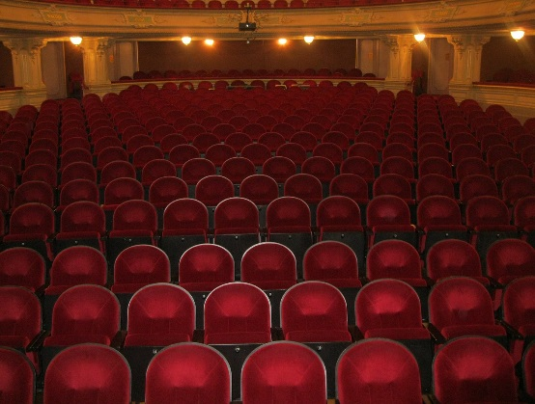
Good images are dynamic and striking. They are high quality, unique, and capture the action and have an emotional pull:
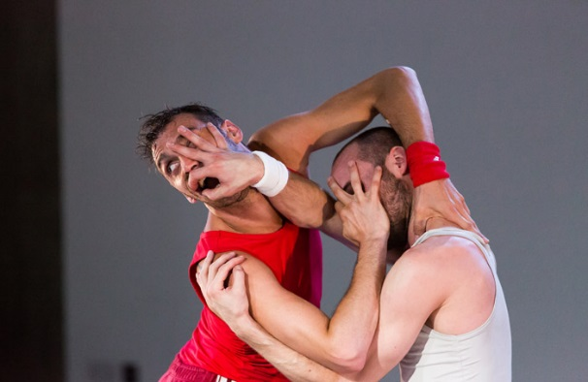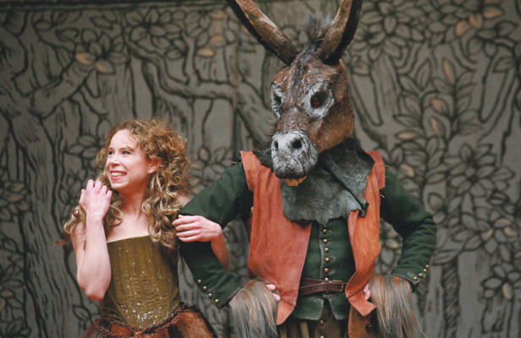

Images for Marketing:

Marketing Video
Social media sites such as Facebook are now video-led, and video can easily be embedded into many venues’ websites. Consider sending the venue video content, or uploading to YouTube and sending them the link. Video can be professionally shot, or you can get great results using a smartphone. Types of content to consider: a short trailer for your show, rehearsal footage, vox pops from previous audience members, or backstage interviews with cast or crew.
Videos for Marketing:

Section 2: Information for Box Office Staff

Box Office Information Sheet
Use the blurbs you have created in Section One to create a handy cheat-sheet for box office staff.
Under the ‘Practical’ heading, give them some things that would be good for venue to know before show begins. For example:
- No swearing/lots of swearing,
- No strobes.
- Need black out at points
- Age guidelines 4-8
- Preference to hold the show if any of the audience are late
- Audience participation at end of show for 5-10 minutes, chance to join in the action at the end

Box Office Information Sheet

Name of show:

Name of company:

Tour Dates:

Tagline:

20 word sentence:

100 word synopsis:

Performance dates and times:

Ticket Price(s):

Booking offer:

Practical Information:

Section 3: Information for Front of House Staff

Cover page for your Front of House Information
If you are sending information separately to Front of House Staff, copy and paste the cover page you created for the marketing staff here.
Company Logo:
Company Name:
Title of Show:
Date of Tour:
Number of Performances:
Contacts for Company:

Timings
Let front of house know any relevant timings for the show. Include details of intervals, black-out lighting, after-show talks, or any audience participation segments. If you have a latecomer’s policy, explain why. Front of house staff may be challenged on this by any audience members who aren’t let in!
Example:
“Running Times:
House Open – 5.45pm
Start Show - 6.15pm
Interval - 7.30pm – 7.45pm
Show Finish -8.40pm
Audience Participation: Voluntary audience participation for first row in last ten minutes of show (8.30 – 8.40pm). Two actors will be off-stage interacting with the audience at this time.”
Latecomers: Latecomers are not permitted after the show has been running for 15 minutes as entrance to the show crosses the performance area.”
Running Times:
Audience Participation:
Blackouts/Explosions/Flame:
Latecomers Policy:

Performers on stage
No. in cast:
No. of performers on stage:
No. of performers backstage:
Are performers pre-set?

Set necessary
Set necessary:

Section 4: Checklist
That’s it! You’ve created a comprehensive marketing guide for your show’s venue which will improve attendance at your show. Now all you need to do is copy and paste the blue textbox information and send to the relevant people. Don’t forget to attach publicity photos if you’re sending via email.
Here’s a checklist of everything covered in this pack:
☐Cover page for you show marketing information
☐Show information and copy
☐Tagline
☐20-word sentence
☐100-word synopsis
☐Style of the show
☐Tour dates
☐Ticket prices and promotions
☐Company information
☐Personnel
☐Suggested target markets
☐Suggested selling points
☐Press release
☐Social media plan
☐Templates for letters and emails
☐Marketing Images
☐Marketing video
☐Box office information sheet
☐Cover page for your front of house information
☐Timings
☐Performers on stage
☐Set necessary
☐ Remember to add any attachments – publicity photos, press release

