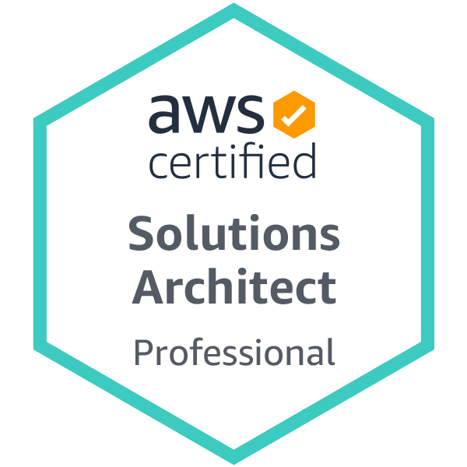Ameen Asif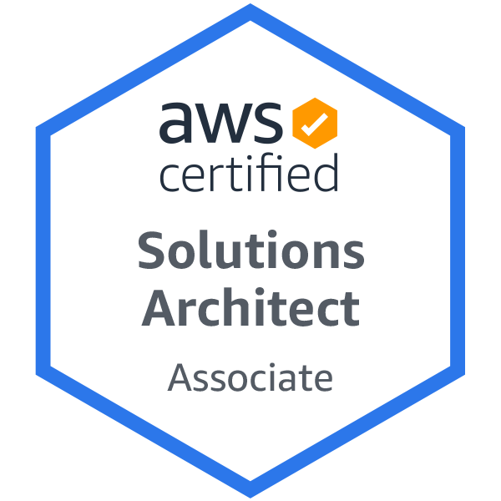 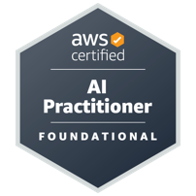

# <https://www.linkedin.com/in/ameenasif/> | [www.ameen.guru](http://www.ameen.guru) | +353 86 8072 514

# Cloud Solutions Architect

Strong in designing Cloud Solutions on AWS (6 Enterprise Projects Designed and Deployed)

## Certifications: AWS Solution Architect – Professional, Associate, Security – Specialty, AI Practitioner, GCP – Cloud Digital leader

## Summary

Over 23+ Years of experience in IT, Strong knowledge and experience in Cloud Architecture and Serverless software development. Delivered 5 Enterprise Cloud deployments with design, governance across multiple co-located teams. Delivered 2 High performance cloud native design solutions.

## Timeline of work experience

Jan 2023 - Till Date : Amazon Webservices (AWS)

Feb 2021 - Dec 2022 : Aer Lingus

Dec 2019 - Jan 2021 : House of Oireachtas

Oct 2017 - Dec 2019 : Bank Of Ireland

June 2016 - Oct 2017 : Dun and BradStreet

May 2014 - June 2016 : Houghton Mifflin Harcourt

July 2012 - May 2014 : Sentenial

May 2006 - July 2012 : Pramerica Systems Ireland

Mar 2006 - May 2006 : MphasiS

Oct 2004 - Mar 2006 : Case Consulting Group.

May 2004 - Oct 2004 : Itellium GmBH.

Sep 2003 - May 2004 : RAFT International PLC.

May 2003 - Aug 2003 : Atos origin India

Apr 2002 - May 2003 : Baha Technologies

Mar 1999 - Feb 2002 : Elysian Global Solutions Plc.

Oct 1997 - Feb 1999 : Tops Sequipments Limited

## Experience Summary

|  |  |
| --- | --- |
| Cloud Migrations | Are Lingus, Dun and Bradstreet, Bank of Ireland, House of Oireachtas, Fujitsu |
| Could technologies | AWS - Elastic Beanstalk, Lambda, EC2, SQS, VPC, Kinesis, Spring Cloud, OpenShift, Kinesis, API Gateway, Elastic Cache, Elastic Search, Elastic File System, Cloud Formation, KMS , Azure, S3, CDN, Step Functions, App Stream, IOT |
| Software / Languages | J2EE, JAVA , XML, HTML, JavaScript |
| Distributed Technology | SOAP Webservices, REST, Micro services |
| Datastores | Oracle, DynamoDB, Elastic Search, MYSql, SQL Server, Time Series |

## Qualifications

Engineering in Aircraft Maintenance. -1996. | Post graduate Software Diploma from NIIT

## Projects:

### **Company: Amazon Web Services (AWS)**

**Role : Senior Solutions Architect**

### **Company: Aer Lingus**

Role : Cloud Solutions Architect

Project : Enterprise Architecture and Design Authority

|  |  |
| --- | --- |
| * Modernize Airline solutions and Data-center Migration to AWS Cloud * Represent Enterprise Architecture in Design Authority * Introduced Cloud native Serverless design for new developments  ( Store first design, AppStream, Lambda, Step Functions, Event Bridge, Quarks, Graph QL, WebSockets, Environment management) * Introduced Realtime comms and Async event driven design * Designed Infrastructure for SL1 and Platinum Applications  1. Airline Information Management System (AIMS) 2. ECrew Management application - (AIMS) 3. Aircraft weight and balance application (Netline -Airbus) 4. Flight planning System (LIDO 4D - Lufthansa) 5. Serverless design for Flight dispatch Document (Enhanced Briefing pack) 6. Revenue Accounting system (RAPID -Accelya) 7. Treasury Management System (TMS - FIS Global)  * Designed Tech Enablers as part of Speed to production   MQ Infrastructure, Managed FTM, Predictive Maintenance (Airbus)  **Received Technology & Innovation Excellence Award** |  |

### **Company: House of Oireachtas**

Role : Cloud Solutions Architect   
The assignment is to mage delivery in 3 project streams:

*Data Center migration* ***:*** Designing landing Zone and Infrastructure network , Connectivity to government networks ,planning migration strategy, Redesign to HA Architecture on Azure , Design Security Compliance and governance model

*Cloud native design for Applications hosted on AWS:*Design HA and High-performance applications, optimize cost

*Migration of Storage Tapes to Deep Cloud Archive****:*** Design and implement migration of data from LTO Storage tapes to Deep cloud Archive

### **Company: Bank of Ireland** Role : AWS Architect /Cloud Config Mgmt. Sr. Advisor

**Project : PSD2 Open banking**

Design Hybrid Cloud Infrastructure for Payment Services Directive Implementation on AWS .  
As a part of the program management and solution Architect team, my responsibility is to design cloud migration of Open Banking Apis for the UK , the solution to be hosted on AWS for Bank of Ireland this included creating supporting infrastructure with all controls and reviews with design and implementation . Daily activity includes

* Solution Design, Security/ Solution review with review board
* Program governance
* Managing multiple co-located teams and vendors
* Plan tactical and strategic risk mitigation
* Prepare Architecture roadmap and milestones

Achievements: Data storage design for PCI DSS data, Delivered first cloud platform for Open Banking api in bank within tight deadlines.

Tech Stack**:** Cloud-formation, API-Gateway, DynamoDB, AWS Lambda, IAM, AWS CLI, Kanban, Microservices, ECS, AppDynamics, Splunk, Infrastructure as code, Performance engineering, Agile design practice, web-sense, Firewall setup, security layers , WAF, NetScaler. PingFederate, Azure AD, SAML, OIDC, OAUTH

### 

### **Company: Dun and BradStreet**

**Role : AWS Architect / Delivery Lead**

**Project : Enterprise Micro-service**

Description**:** Deliveredthe Opensource Cloud native design from existing OSB Service in data center to Microservice Architecture on AWS. The project challenges included managing migration of legacy code with no documentation with new teams, planning and training members of developers and operations for cloud methodologies and establishing process improvement to align with ISO Compliance.

* Design and develop OSB solution to Micro services Architecture
* Work closely with the Business and Enterprise Architect team in the US to ensure the Migration is in line AWS Cloud Best Practices.
* Manage Performance Engineering.
* Ensure product is scalable vertically and horizontally and identify the utilization gaps in cloud infrastructure.

Achievements: 75% savings on Infrastructure cost, Dynamic creation and shutting down of test environments

Tech Stack: CloudFormation, Elastic beanstalk, Elastic Cache, Elastic Search, Lambda, Spring Cloud Config, Spring Boot, REST, XML, SAML, OAuth, Jbehave, Jenkins, Maven, GIT, Amazon Kinesis, Hystrix, Elastic File System.

### 

### **Company: Houghton Mifflin Harcourt**

Role : Technical Lead - Identity management

Project : IDM

Description**:** the project is to enable Single Sign On with all United States districts with HMH products, design and develop provisioning solutions and migrate web-based products to SOA Architecture and ensure the performance is met with current and increased volumes. I am responsible for:

* Design and develop Transformation to SOA solution from multiple web applications.
* Implement Oauth 2, open-id connect Authentication
* Prototype Elastic search and Amazon Kinesis for real time data analytics.

Achievements: Designed High Volume batch processing 50Million transactions in 4hours, 5Million single sign on identity federation using SAML, Oauth, OIDC

Technologies **:** Elastic Search, Spring, ibatis, Tomcat, WildFly9, REST, SAML, OAuth, OpenID Connect, Spring security, Spring Batch, Bamboo, Maven, Amazon Kinesis, Kibana, AMAZON EC2, Hystrix, Drop wizard.

### **Company: Sentenial**

Role : Technical / Product Architect

Project : Origix Corporate , Origix IP, SEPA PAYMENTS

Description **:** Origix Corporate, Sentenial ‘s corporate product suite, is a complete SDD compliant payment processing solution.I was responsible for upgrading the technical design for cloud, setting up identity federation (SSO/PKI) between the product and major banks

Technologies **:** Spring, Hibernate, JBOSS EAP 6, Web-services, XML, Ping federate (SAML), PKI Gemalto Smart card, HornetQ JMS, Spring security, Spring Batch, Message Driven Bean, Quartz Scheduler. Selenium Itests, Junit, Jenkins, Maven, SVN.

### **Company: Pramerica Systems Ireland**

Role: Principal Support Engineer

Description **:** Lifeportal /eDG encompass the middle-tier and Portal solution and the business tier for various Prudential Portals and web applications. A set of Infrastructure services using CORBA technologies, Web Services that interact with the Mainframe back end to serve client applications

Environment: IBM Portal JSR 268, CORBA, Web Services, Servlets, XML, XSLT, MQ Series, RAD 7.5. HTML, WebSphere, Castor XML, Asynchronous beans, SAML, TAM

### **Company: Mphasis**

Role: Project lead

Description **:** The project was a health care product migration from legacy client server to web based J2ee technologies. The product was built on HIPPA standard.

Environment: Struts, Spring, Hibernate, Servlets, JSP, Tomcat, Oracle, XML, Java-XML Data Binding, Enterprise Architect, UML, ANT

### **Company: Case Consulting Group - [ CP SHIPS].**

Role: Team Lead

Description **:** The project referred as Galleonscope comprises of developing and maintaining the infrastructure software that acts as a backbone of Shipping Business

Environment**:** Weblogic7, Enterprise Architect, Eclipse, Castor XML, JMS EJB 2.0 Struts, J2EE, Oracle 8i, ANT, AS400, CVS-NT, Hibernate, AS400, Crystal Server, EDI, MQ Series, DB2 and Oracle Database.

### **Company: Itellium GMBH. - [ KARSTADT - Germany].**

Role: Consultant

Description **:** The project was on retail domain for creating a centralized web based system to replace the existing Fat client and re designing the system based on the changing business rules for label printing, Price promotion.

Environment:WebSphere 5, Magic draw, WSAD, Struts, Oracle 8i, ANT, CVS-NT, Hibernate

### **Company: Raft International Plc. [ABN AMRO, Barclays capital]– UK.**

Role: Tech lead, Scrum Master

The Sarbanes Oxley project scope includes implementing Operational Risk Management System with new actors such as Investigator, External Auditors to record Sarbanes Oxley related data.

Environment**:** Borland Enterprise Server, Tomcat 4.1.27, Enterprise Architect, Maven, Eclipse M7, Struts, J2EE, Oracle 9i, CVS-NT. WebSphere 4, Oracle 8i, MS SQL Server.

### 

### **Company: Atos Origin**

**Project:** Business Configuration Management.

#### Role: Consultant - Contract

Environment:Tomcat 4.1.24 server, Java, JSP, JDBC, JavaBeans, Oracle 8i, HTML, JavaScript

### **Company: Baha Technologies - Rabih Trading (UAE – Dubai)**

Project Duration: 14 Months

Role: J2EE Developer

**Environment:** J2EE, Servlets, JSP, Java Beans, Java Mail API, Oracle 8i

### **Company: Elysian Global Solutions PLC**

Role: J2EE Developer

**Projects:** Global Solutions (UK London), MasterEngg.com B2B Portal, Indian fashion point, Global Insurance**,** Java mail Server, CMS System for British Council of Wolver Hampton (UK – Wolver Hampton)

Duration: 24 Months

### **Company: Tops Sequipments**

Role: Software Developer

Project Duration: 27 Months

Develop and maintain Access Control integrated with the payroll System.